Discussion Time: 15:15 - 15:22



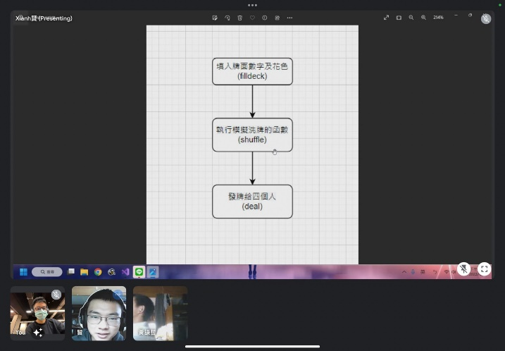

P10-7

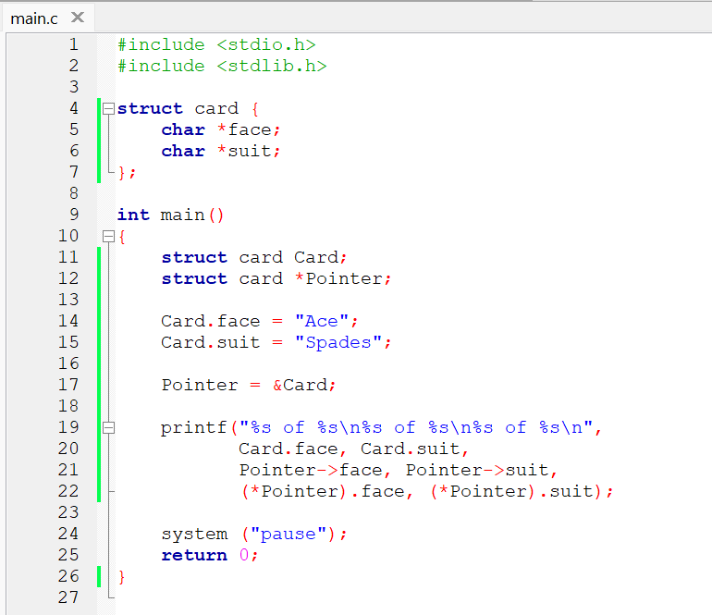

P10-9

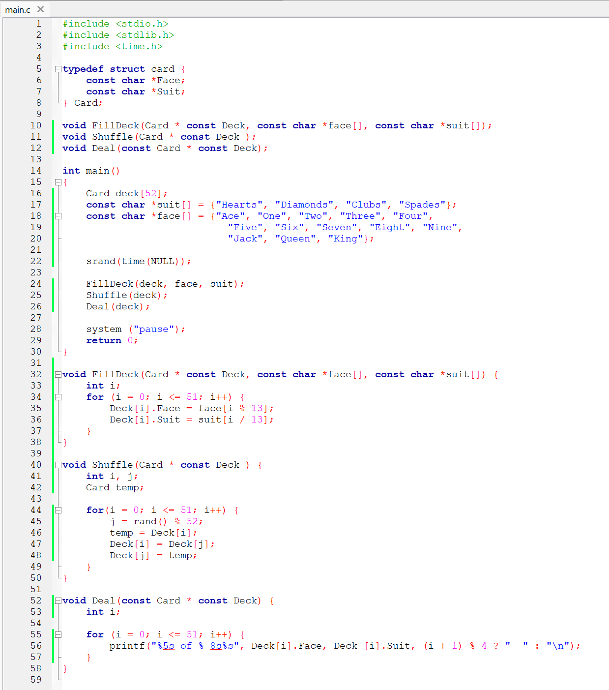

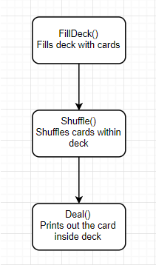

Conclusion:

With the use of structure, you can organize your data types in to multiple groups. Using typedef allows us to use the data type more easily, without needing to attach struct behind the data type every time. The fact that the data type is grouped, modifying a specific data within the structure requires additional information. The additional information would be adding a dot between the structure and data type within structure.

Code: <https://github.com/AldrichWijaya/Homework.git>